Questions For Conference Call 11/6/18  
  
  
From Oct 22nd - Pratik you wrote:  
The remaining points from Saturday 20th oct related to the functionality will be completed after 31st of the October As the head developer for the project is on leave. - Where are the functionality points? Are they completed yet?

**points remaining as mentioned by client over 20oct points**  
- client name appear on the calender  
-the arrow issue  
-Copy url of trainer  
-email changes and the cliclable links.  
**-please submit confirmation if completed or reason if incompleted.**

MAC and OS?   
  
How come FAQs/HELP appears on the Home page section and not the HELP section?  
 Please fix this and put it in between the Terms of Use and the Contact Us sections.

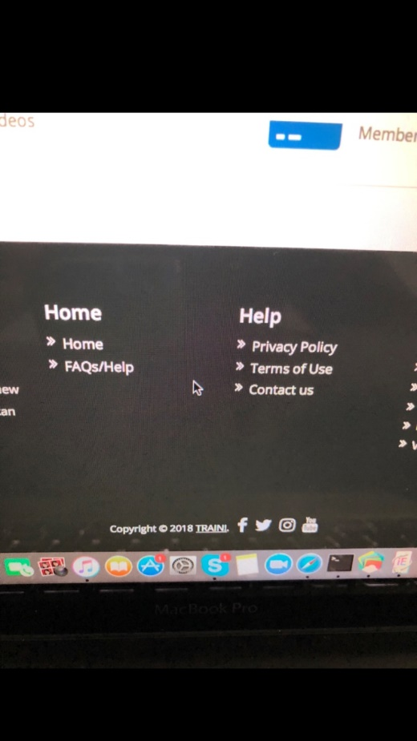

NOTIFICATIONS  
  
  
Both Trainer and Client  
text change: This should read you have 0 new notification(s)   
  
Add new and the (s) after notification

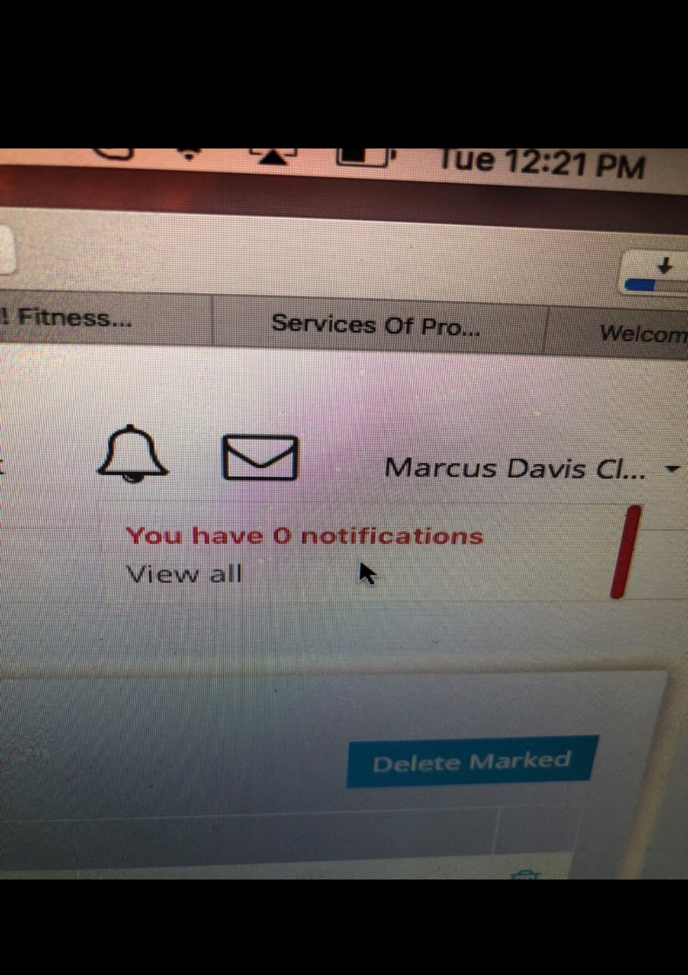

TRAINER NOTIFICATION  
This should read Confirm Session in Blue and Deny Session in Red.

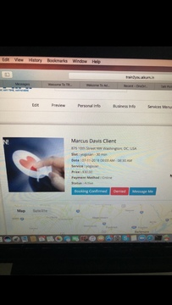

When I press the back button on the notification page then it should take me back to the previous page. I pressed the back button after viewing a notification from a client requesting a session on the Trainer5 page and once I click on that notification it takes me to the confirmed, or deny page but when I press the back button it takes me back to the “My Bookings” page. When I press the back button it should take me back to the “My Notifications” page. SOLUTION: (They are adding an “View All My Bookings” Button next to the back button.

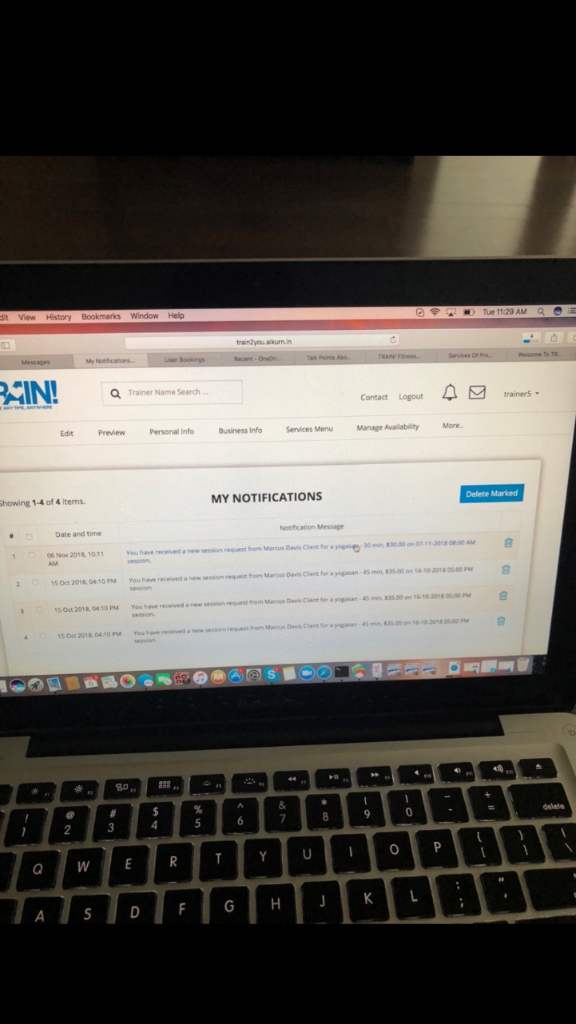

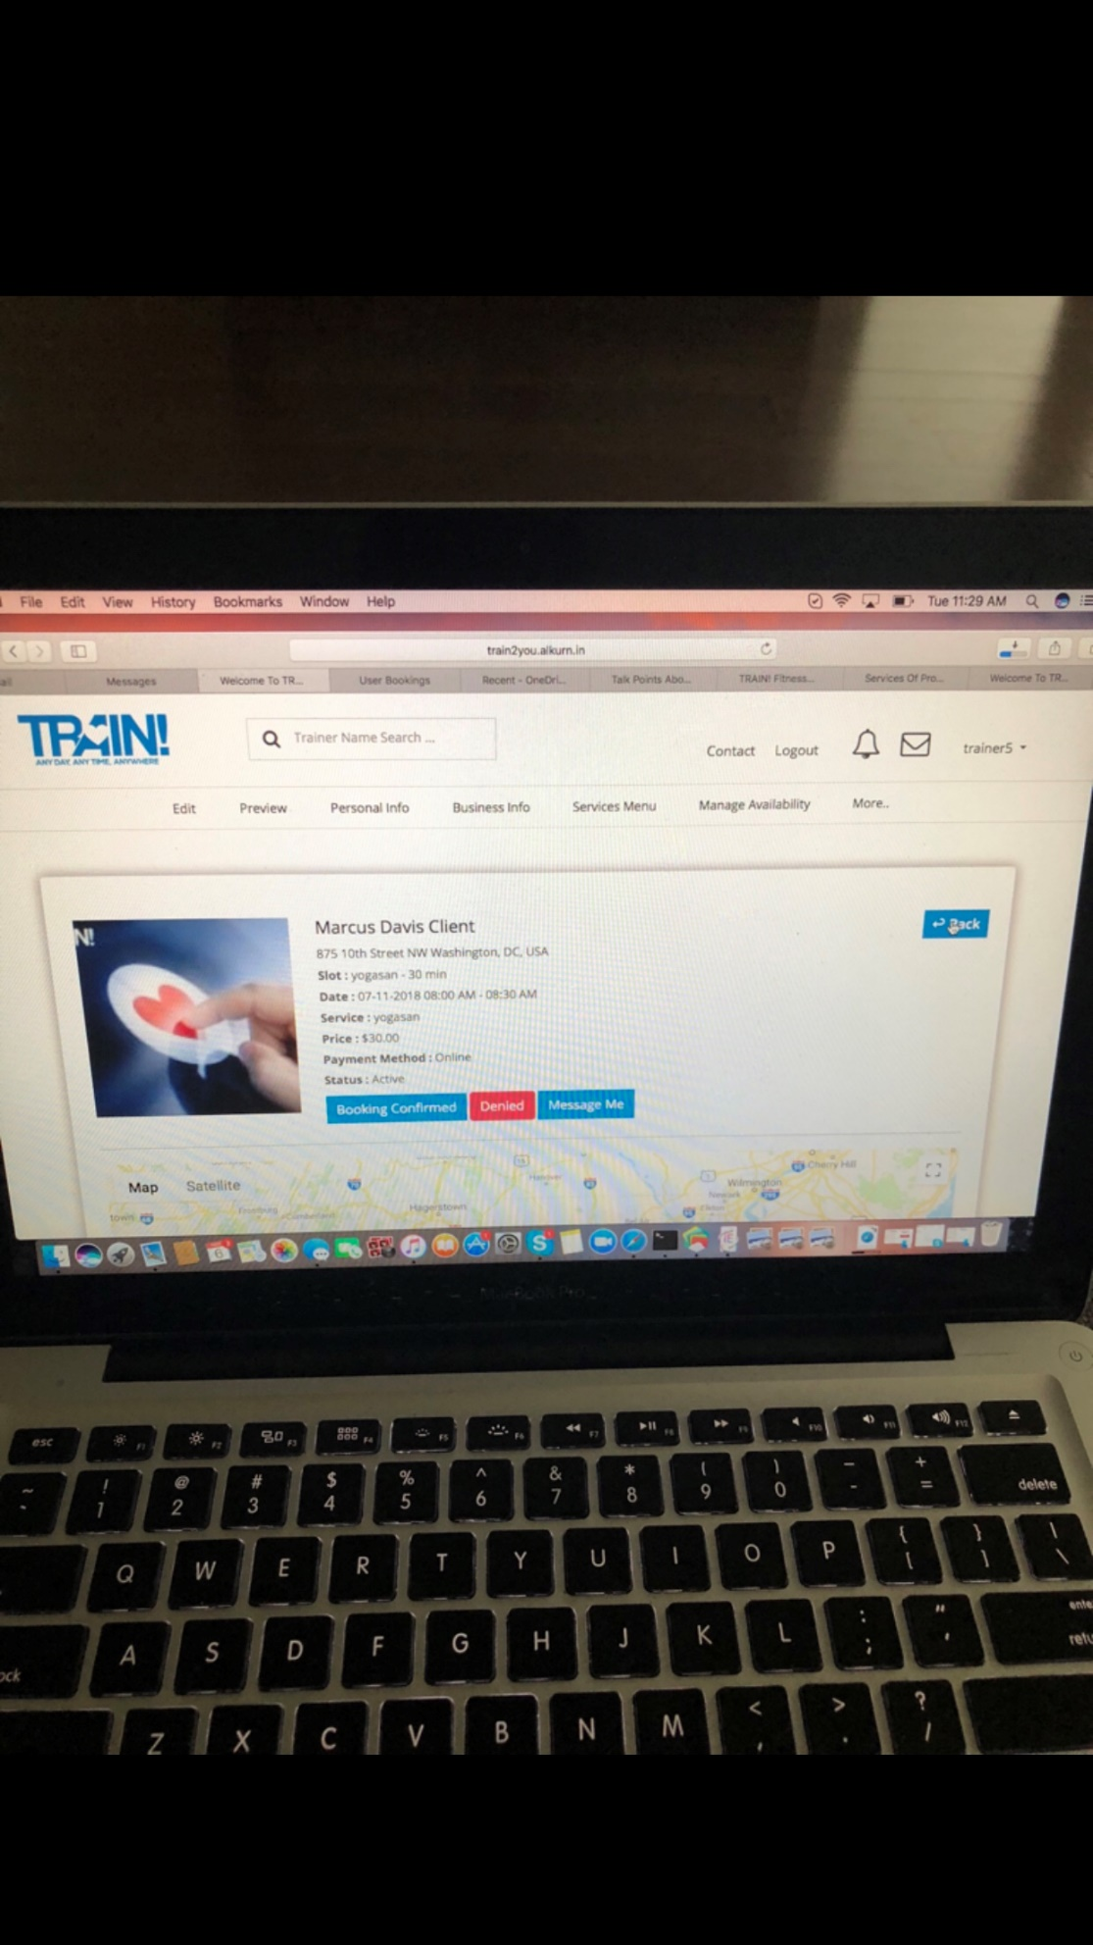

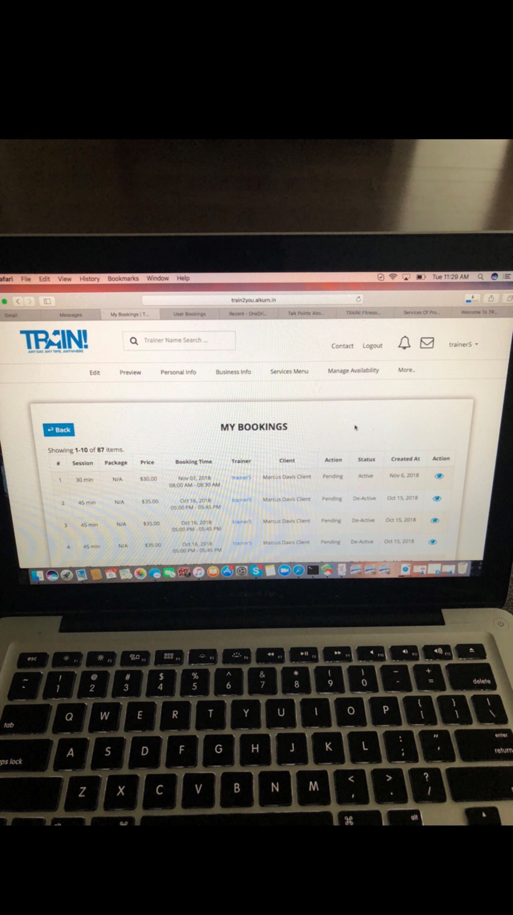

TRAINER PAGE - Preview Page, Add Service  
  
If I turn a setting off then I should not be prompted to enter a price. I should be able to save my settings. Not all trainers will offer every single minute duration for theirs services.

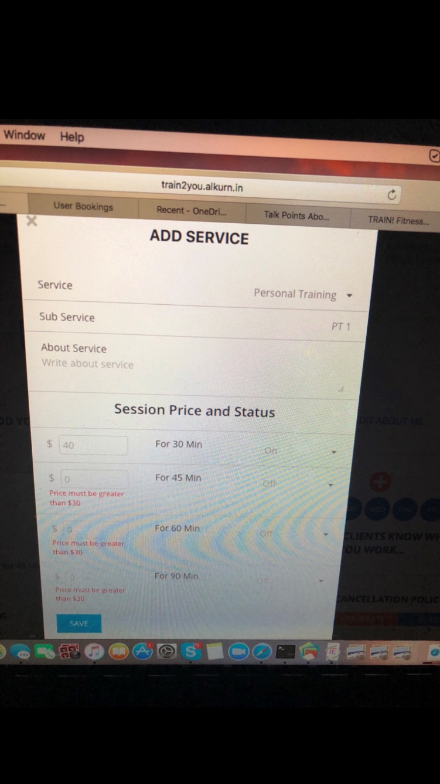

Search Bar - There should NOT be numbers 13, 14, 15 etc... It should be like the regular booking pages example the calendar for a trainer. This means that there should be AM and PM options. Please fix this to make it more user friendly. (NO MILITARY TIME!)   
  
12 Hour Time Frame.

Please see url: https://drive.google.com/open?id=1md15kxbVDuXURa2oPcV35vInMpm2blBv

Search Bar - This doesn’t pre populate matching names like the main search bar above. Trainer Name Search. Please fix this.

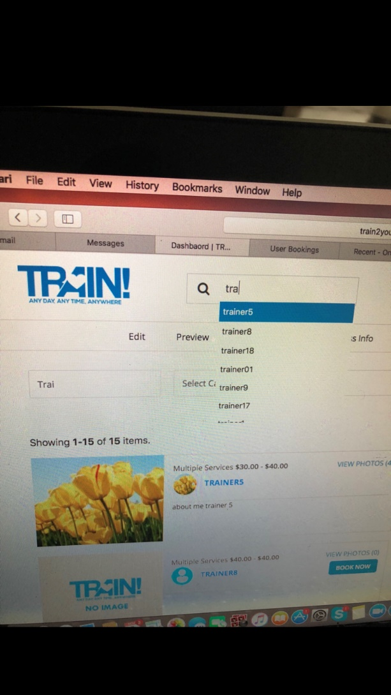

CALENDAR  
On both trainer and client pages the calendar arrows are still not fixed. (THEY NEED TO BE THE SAME SIZE.)

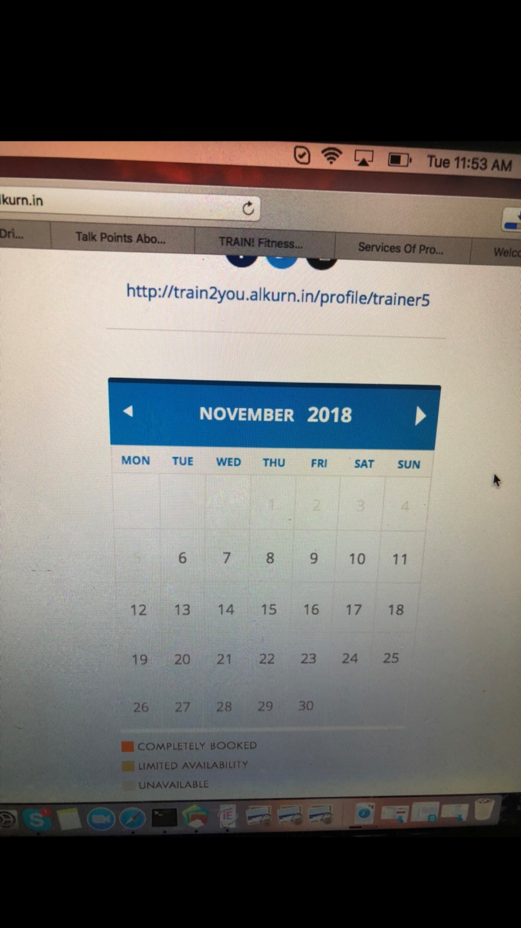

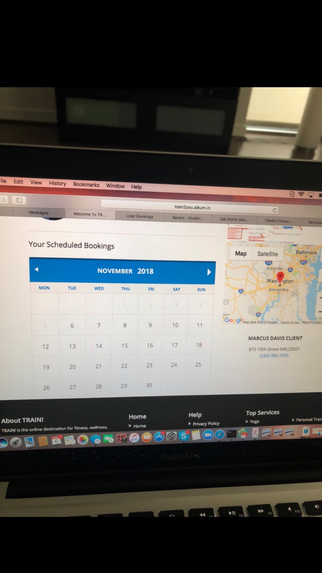

NOTIFICATIONS- We still have not seen the notifications wording that we submitted over in a document. There are no links that were sent to us displaying those changes. (The Google Drive link from Nov 2nd does not allow is to see those changes.)  
  
Setup My Business - I’m trying to create a new account and it’s not working. I already have an account with this phone number. Is that the issue? (We are agreeing that one phone number can be used per account. Even if the user has several emails.)   
  
Logout: not working

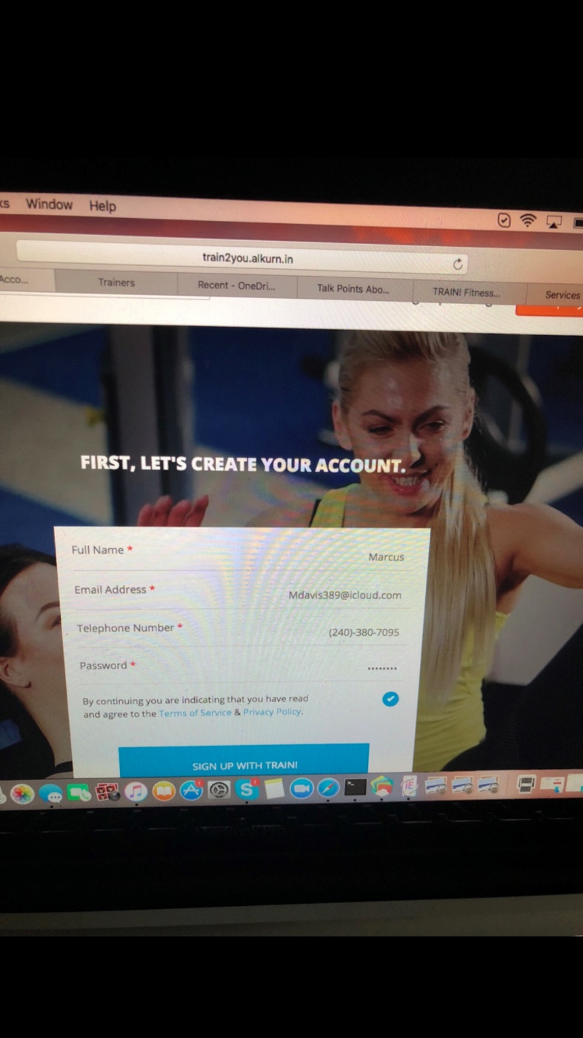

On the subscription page we would like to add the following wording below.  
  
Underneath FREE FOR 30 Days  
In Parentheses  
(We guarantee an increase in new clients and productivity within 3 months or your money back.)   
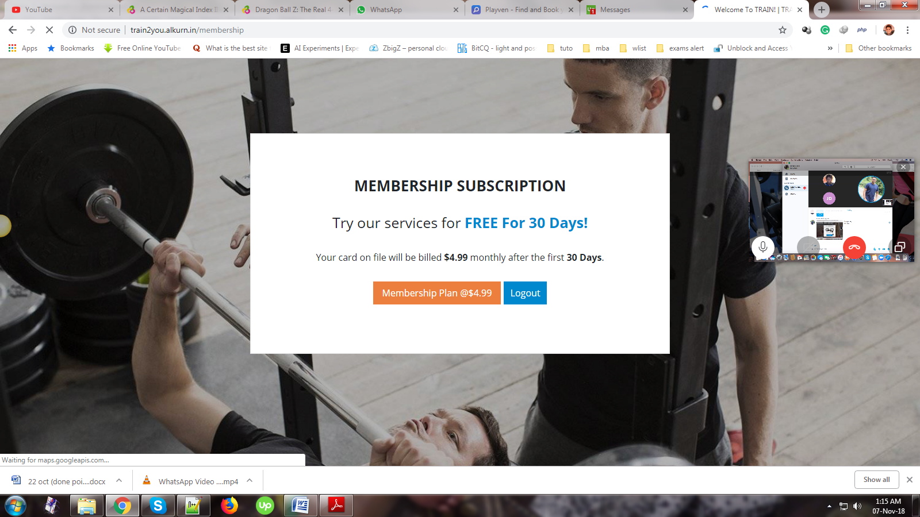

ADMIN Dashbard, Latest Trainers -  
  
Completely Booked on a client calendar underneath it should say “Booked Sessions” :white_check_mark:  
4. I can’t see the full page of a trainer. Part of the screen is cut off. Please fix this.

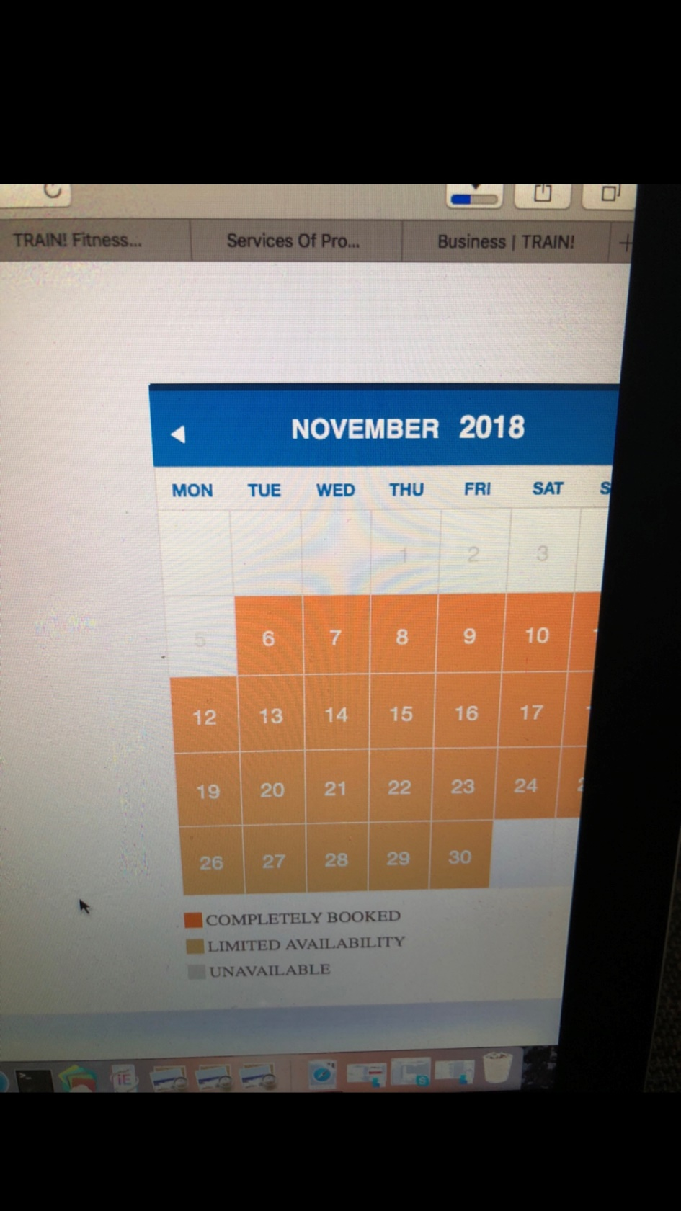

NEWEST POINTS ON UPWORK!  
Also cover all topics that I sent over after that document to see if they have completed them yet.  
  
MOBILE - When will mobile be 100% Completed so everything on the website including the Admin website fits the screen properly? IOS/Android etc...  
  
Pratik’s Comment - In the meantime we will be proceeding with the mobile responsive phase of the website as it will also take time to make the website mobile responsive, for the same we have the following query:

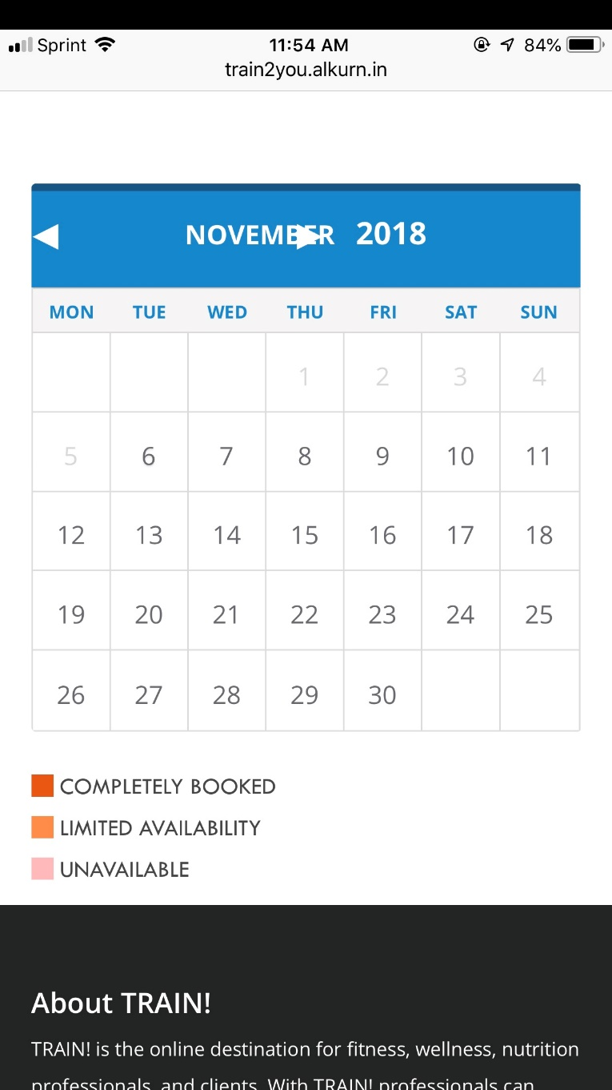

LASTLY  
(Talk About Live Server Testing)  
  
NOW DISCUSS THE LIVE SERVER DOCUMENT!  
  
What will the on demand area and button look like, the site was never updated to show this. For Phase one and phase 2.

The stripe setup for providers should only require a debit card number from the provider to verify bank, identification, and deposit information. Please make sure this is the stripe process that’s implemented. Stripe has made several updates to their processes and this was one of the major updates.   
  
What is the exact date the phase 2 will be deployed - By Monday! 12am EST   
  
We provided your team with the Mailchimp credentials so we can communicate with providers and clients on TRAIN!, has that been set up yet?